Practical - 13
Practical Title: PHP JSON API and AJAX/Fetch-Based CRUD without Page Reload
Create simple PHP JSON API endpoints for events or students and
consume them using Fetch API. Perform list, add, update, and delete
operations asynchronously without full page reload.

Theory
1. Do PHP endpoints return valid JSON responses?
Yes, the PHP endpoints use header('Content-Type: application/json') and format output using json_encode(), ensuring response payloads are returned as valid JSON objects.
2. Are GET and POST requests handled properly?
Yes, incoming HTTP requests are checked using $_SERVER['REQUEST_METHOD'] to direct data fetching via GET and form submissions or database modifications via POST.
3. Are loading, success, and error states shown on the frontend?
Yes, the frontend interface updates dynamically by displaying loading indicators during data fetch calls, followed by success alerts or inline error messages upon response completion.
4. Is input validation performed before database operations?
Yes, input parameters undergo validation checks both on the client side using JavaScript and on the server side prior to executing prepared SQL statements.

Output
- Structured PHP endpoints to handle GET and POST request routes and send JSON-encoded responses back to the client.
- Enforced input validation across frontend scripts and backend procedures before executing database queries.
- Implemented dynamic user interface updates to display distinct loading indicators, success confirmations, and error state alerts.

To View Code: https://github.com/shreyajodhani/studenthub.git

Evidence of Work (Screenshots)
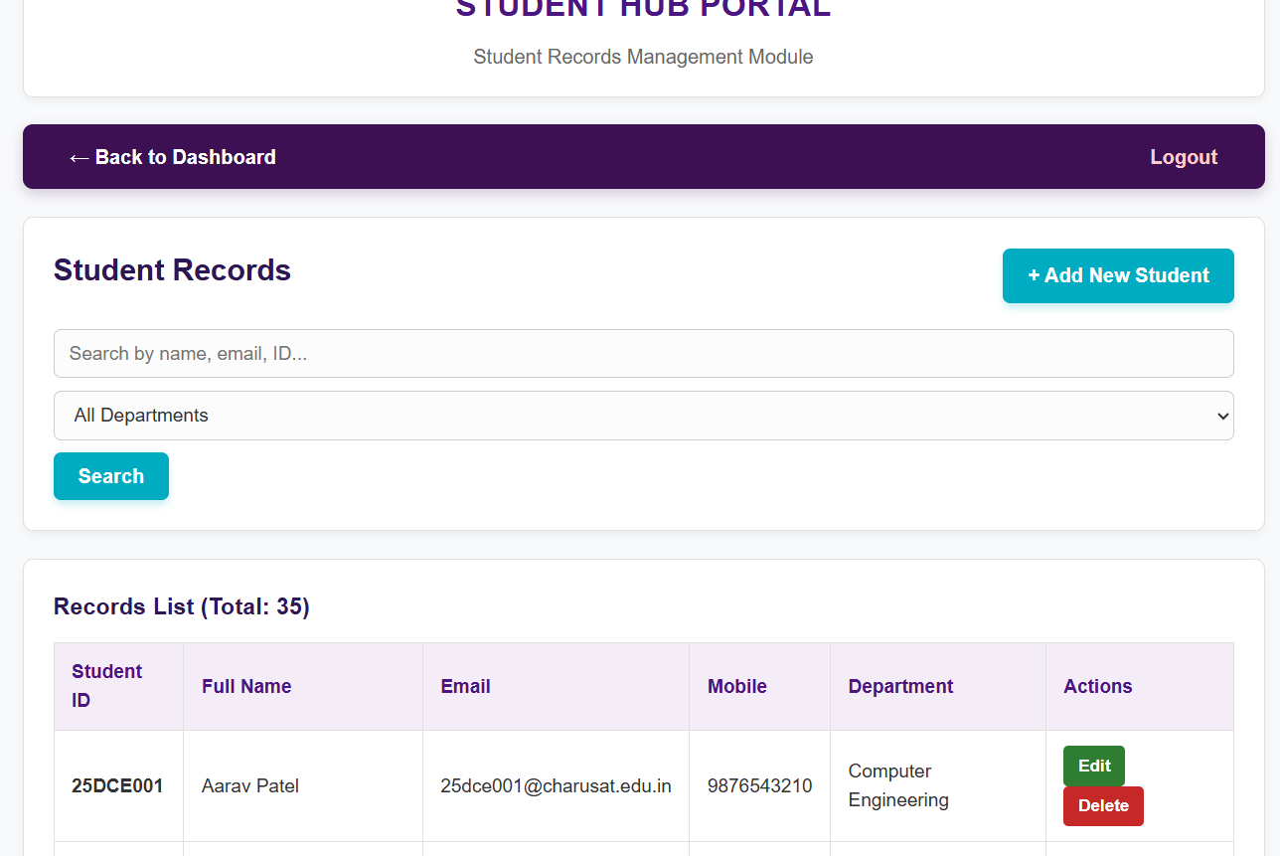

Description: operations happening without full page load.

GitHub Repository Link: https://github.com/shreyajodhani/studenthub.git

Learning Outcomes:
Can do operations asynchronously without full page reload.
Faculty Remarks: (Keep this blank for faculty)

